Home Page:

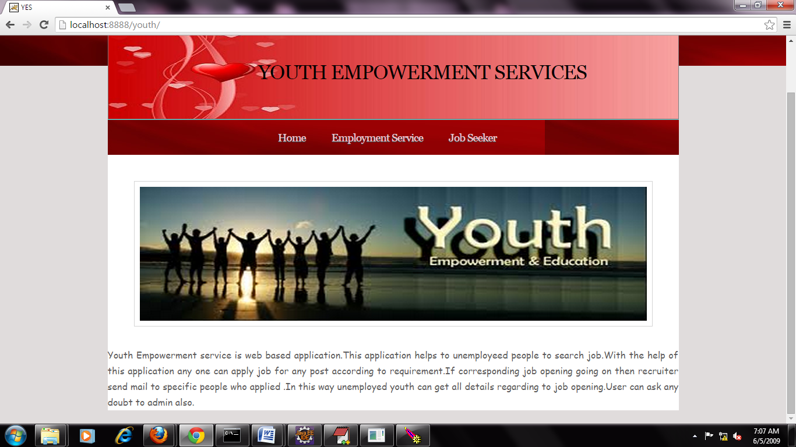

Click on Employment Services:

Then Employment service login screen is visible.

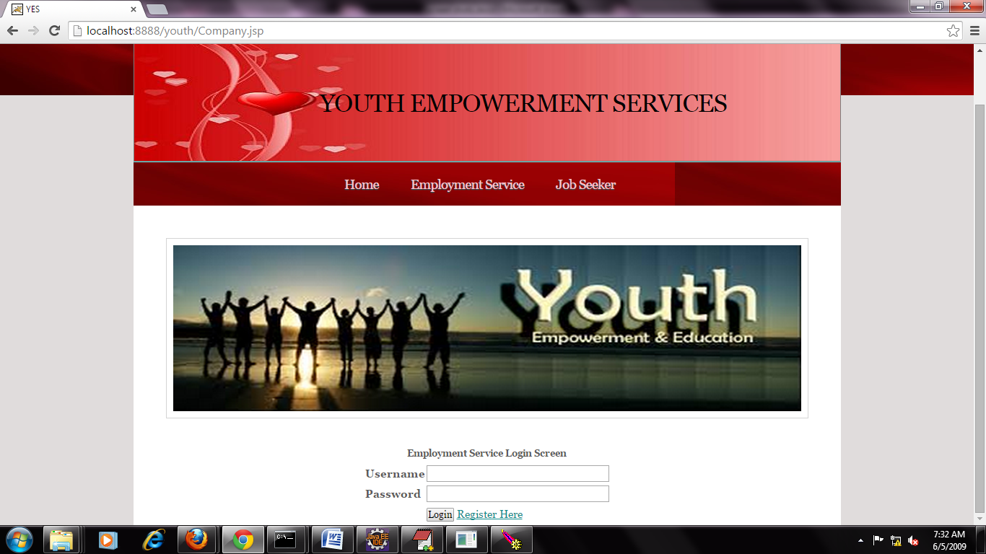

If your new user , Then Click on Register Here link. Then Employment Service Register Screen is visible:

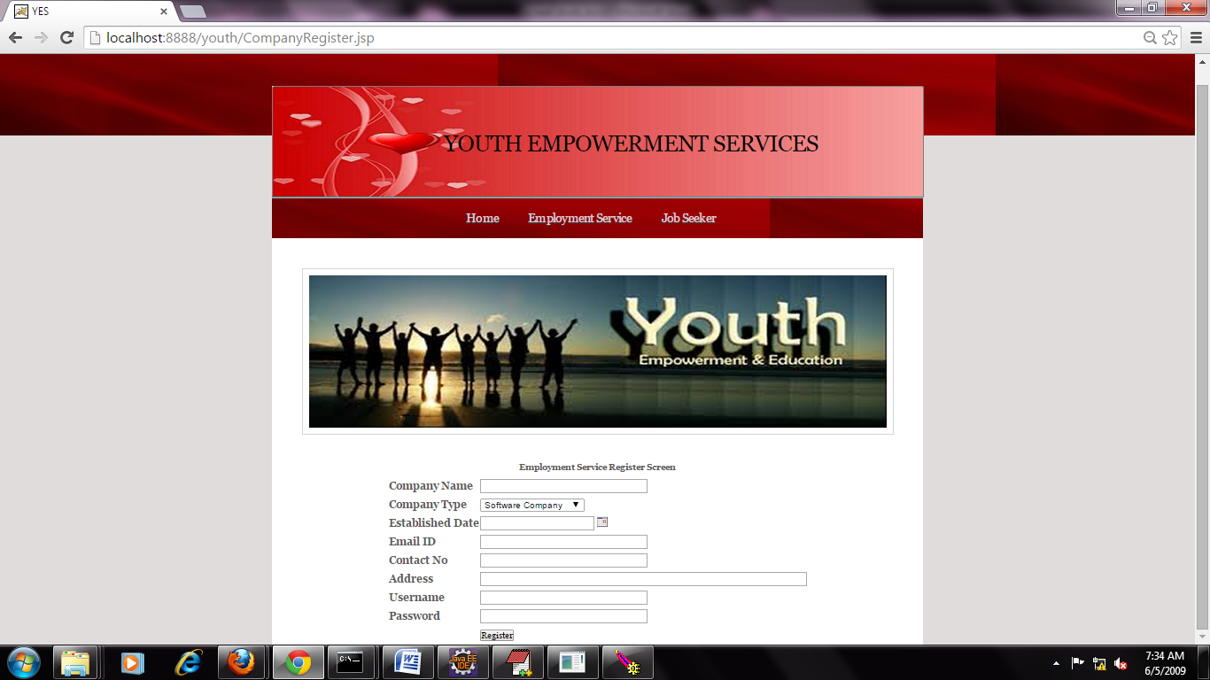Enter all fields to registration and Click on Register button.

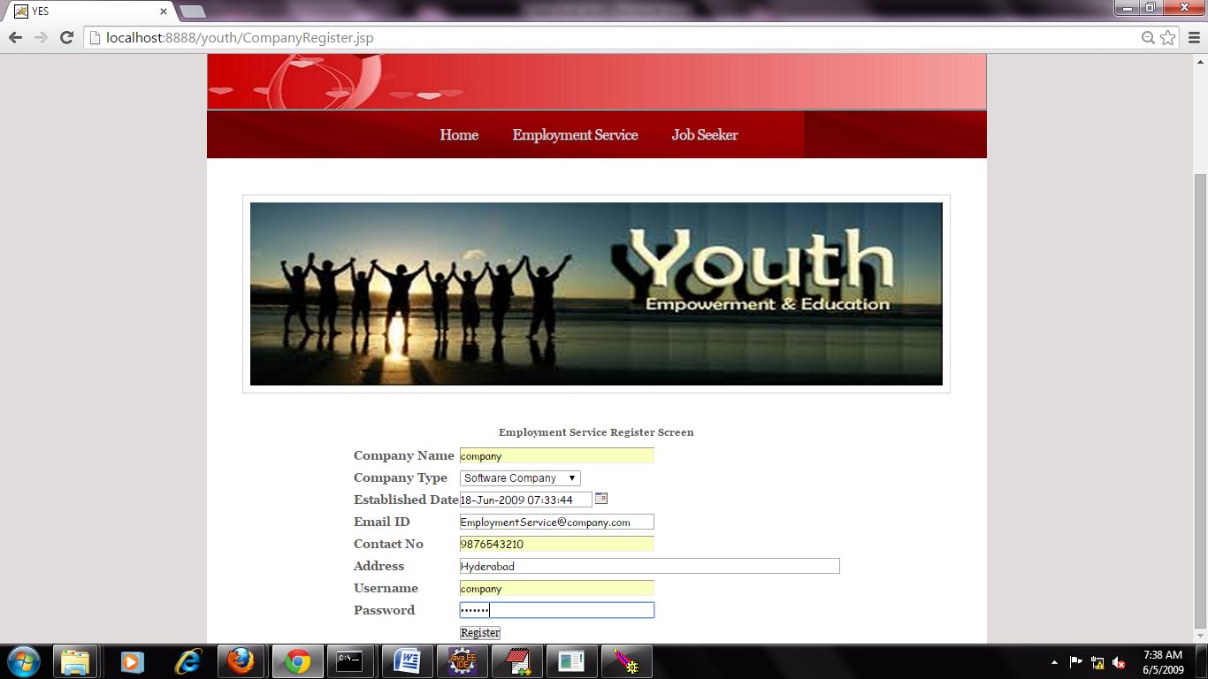

After registration success message displayed on the screen.

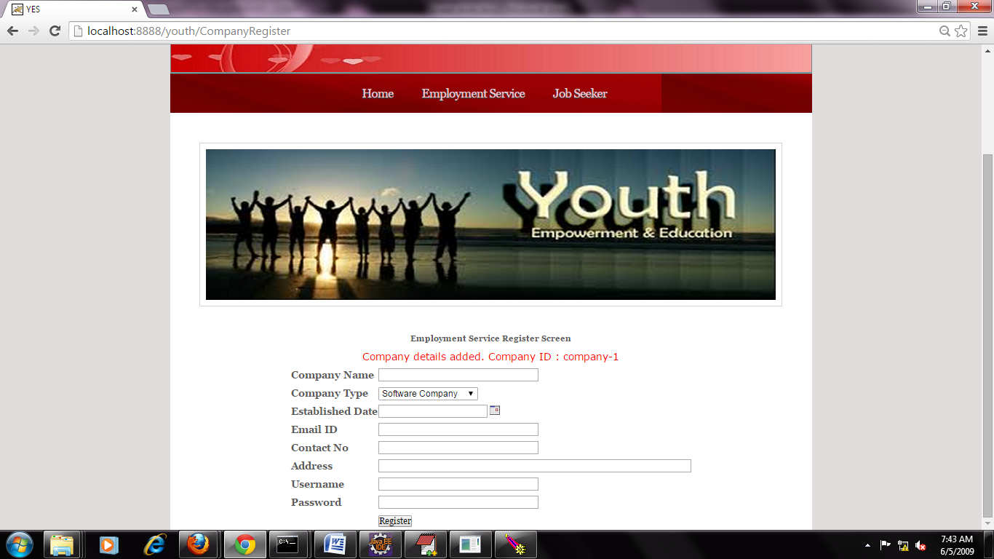

And again click on Employment Screen tab, Then visible the Login Screen , And Enter User-Name and password. After click on login button.

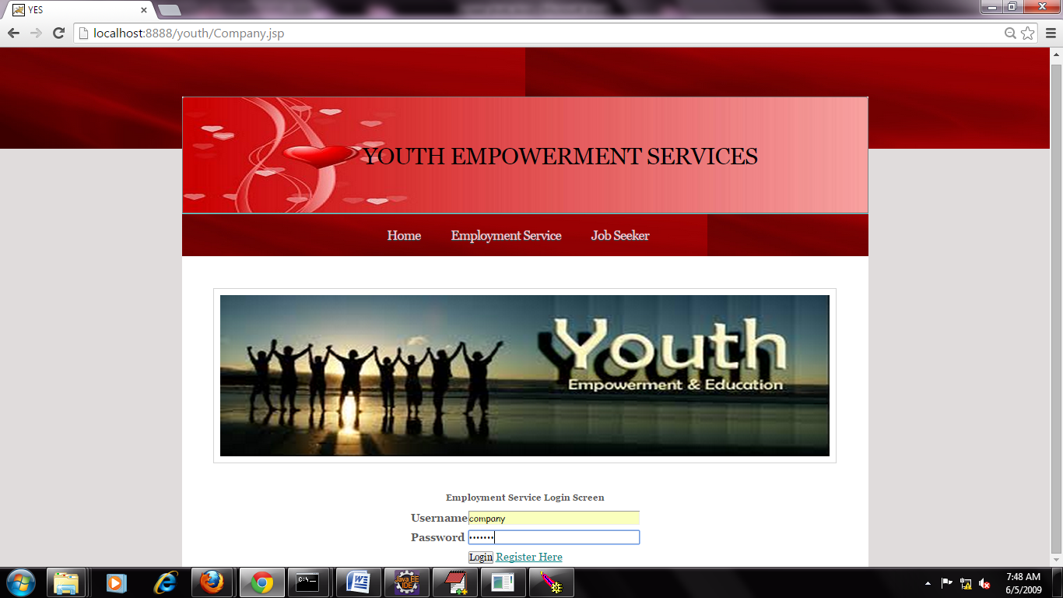

After Employment Service home is visible.

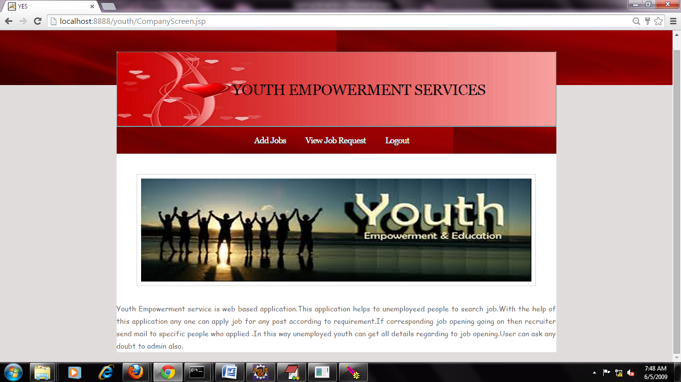

And Click on Add Job Button. Then Add job screen open, there you enter job details to publish job seekers. Finally click on add job button.

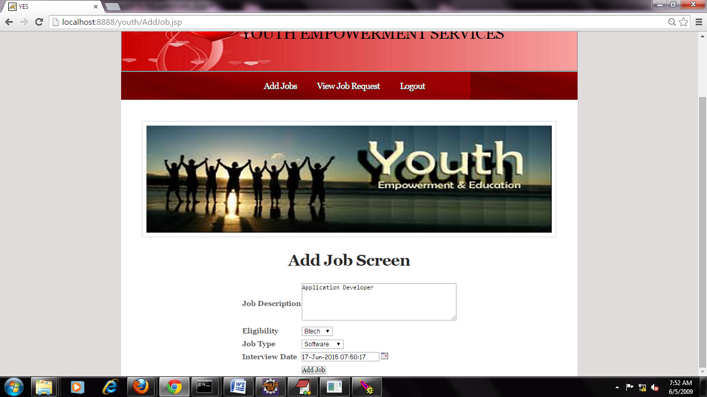

Then job detail added message is appeared on the screen.

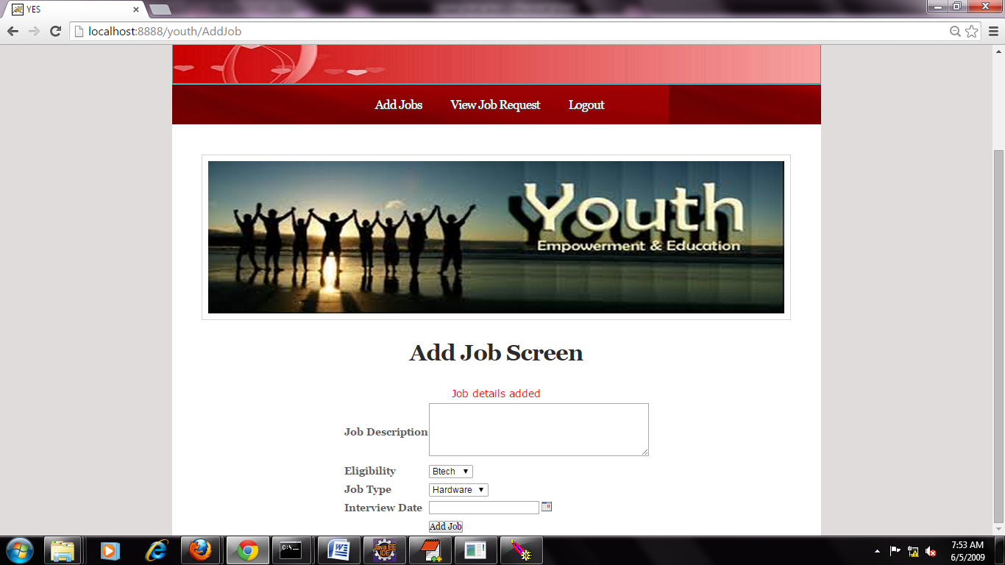

Click on Logout button. Then home page in open. After you click on Job Seeker tab, Then Job Seeker Login screen is visible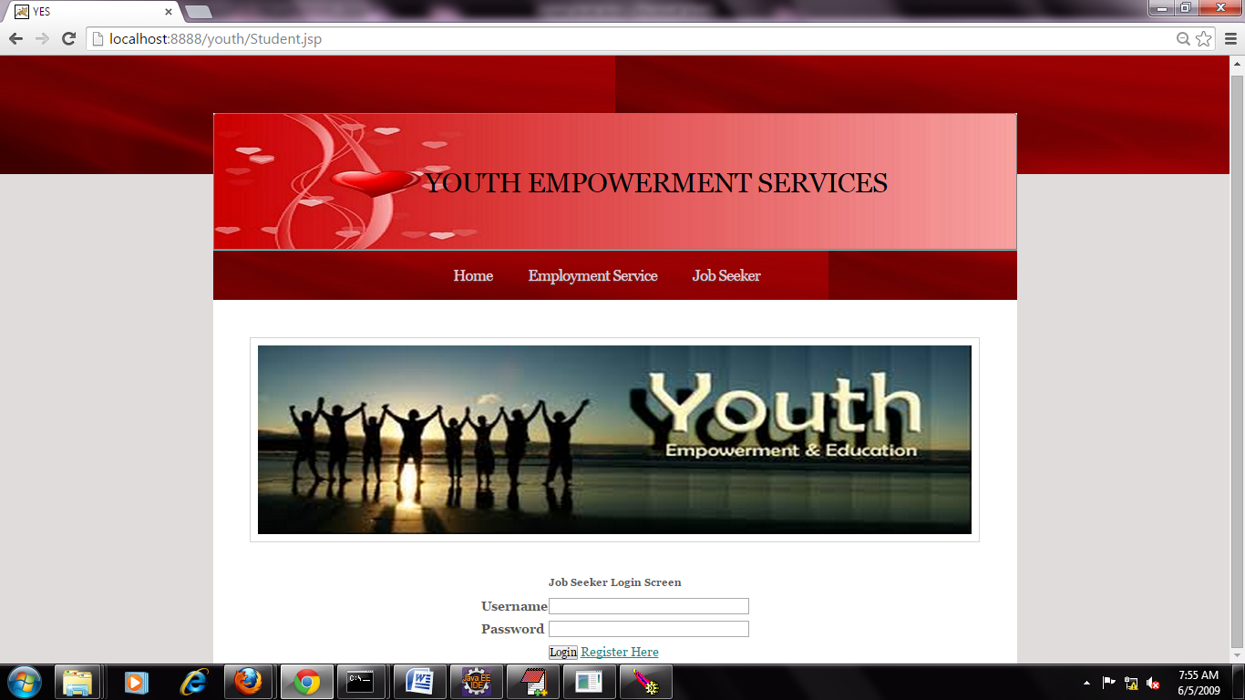

If you are new user to this site. Then you click on Register Here Link. Then Job seeker Registration screen is open.

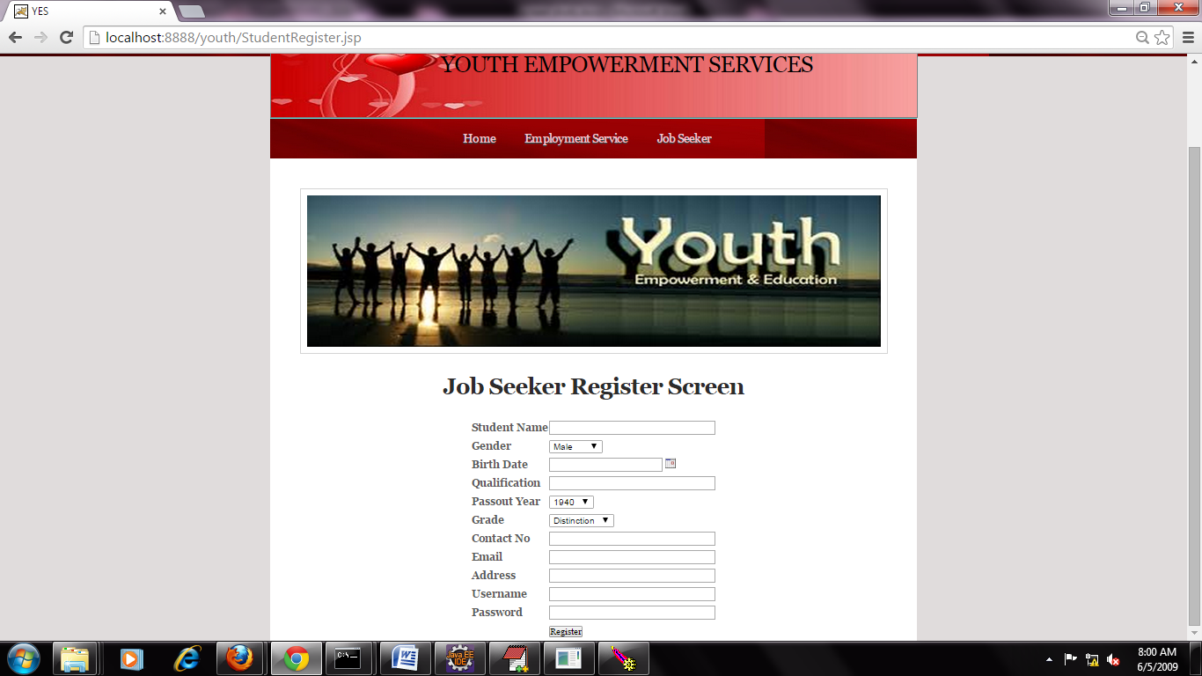

Enter all fields in registration form, Then click on the Register Button.

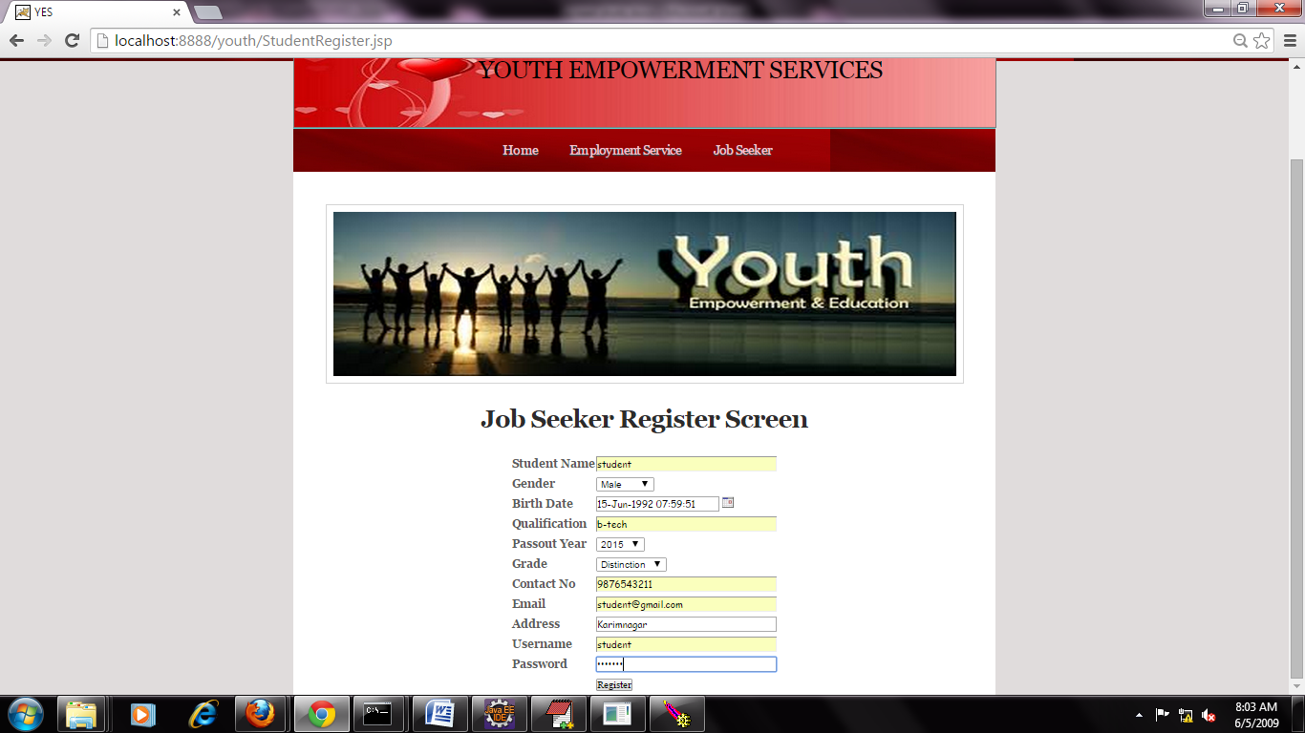

After click on Register button. The student details added message displayed on the screen.

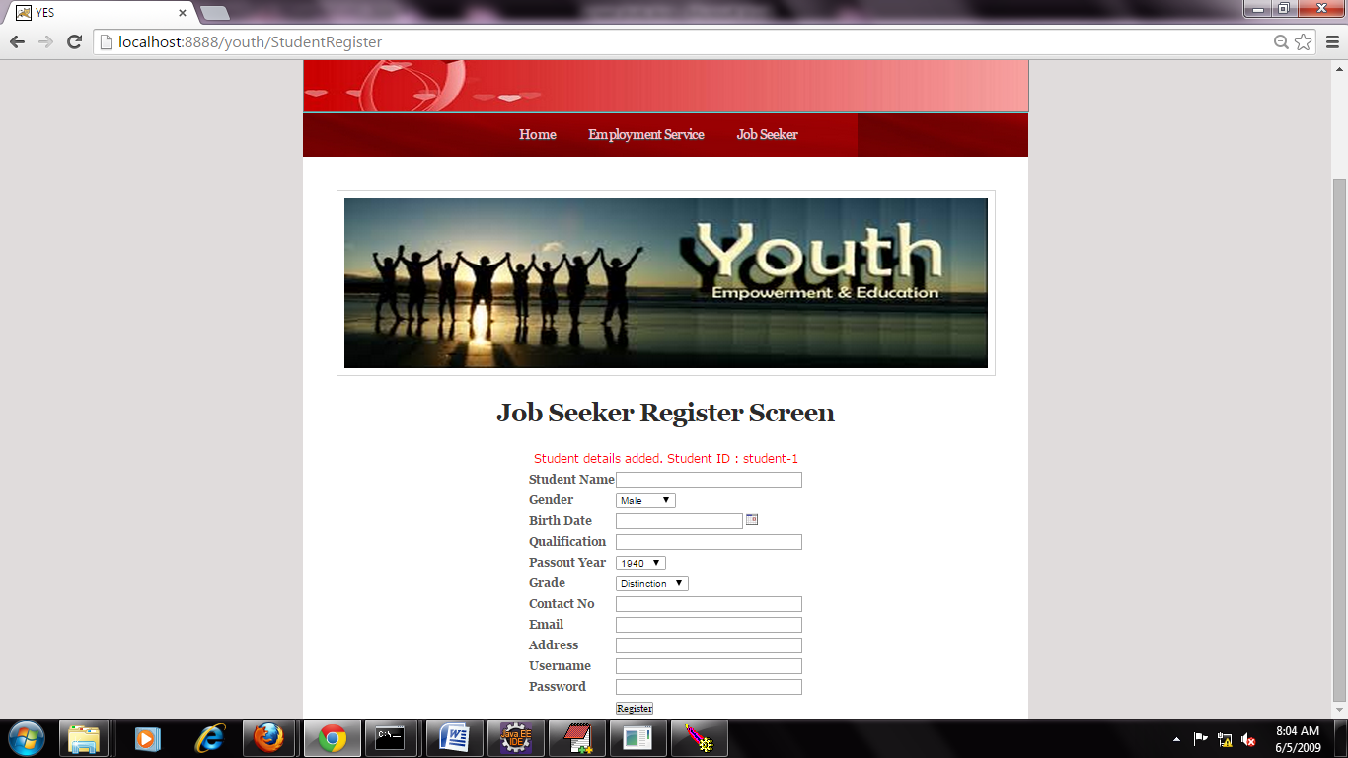

Again click on the Job Seeker tab. Then job seeker login screen is open. There you login with valid user name and password. Then Click on Login button.

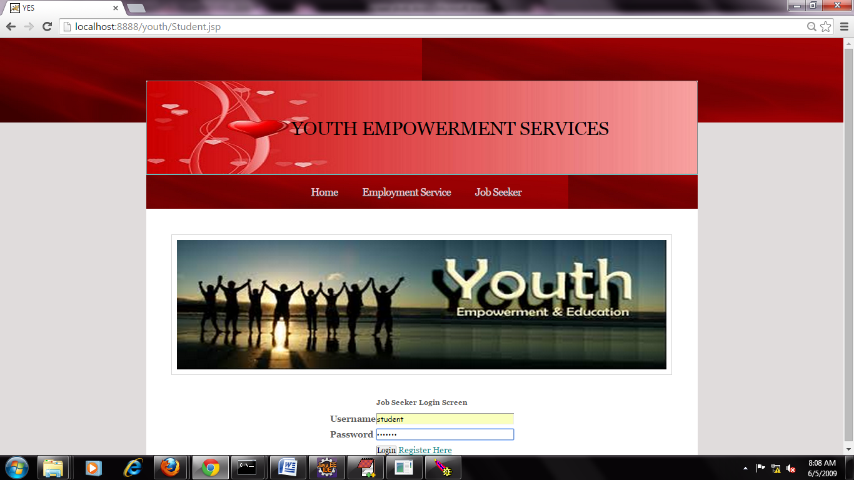

After click on the login button , then job seeker home screen is open.

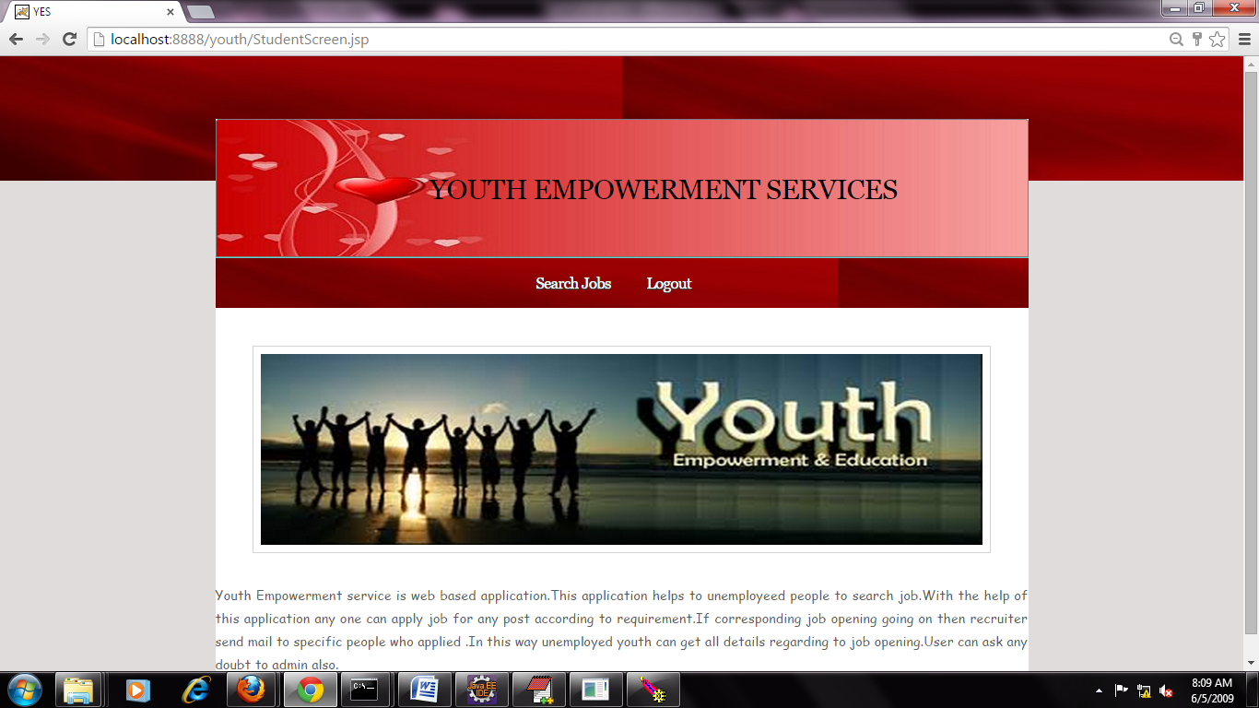

After click on search job tab. Then job search screen is visible, There you select required job type. Click on job search button.

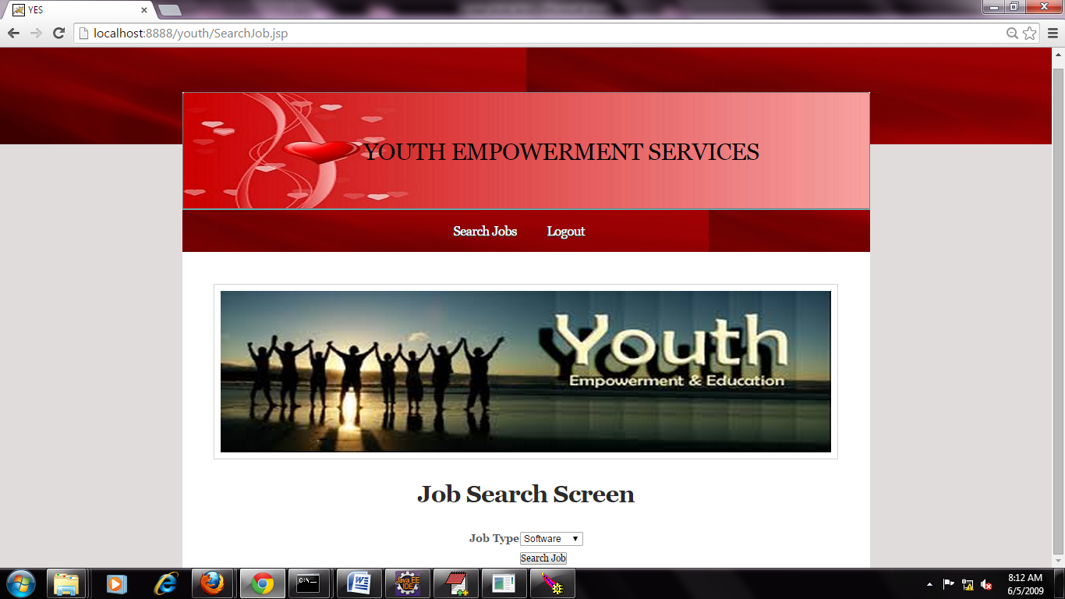

After click on job search button then you will get published job details on the screen.

To post request to the job then click on Click Here Link.

After that process , you are getting success message on screen.



Click on Logout button. And again login with Employment Service provider. Then click on View job Request tab in the Employment service home.

Then the service provider side open view job request screen with student applied details.

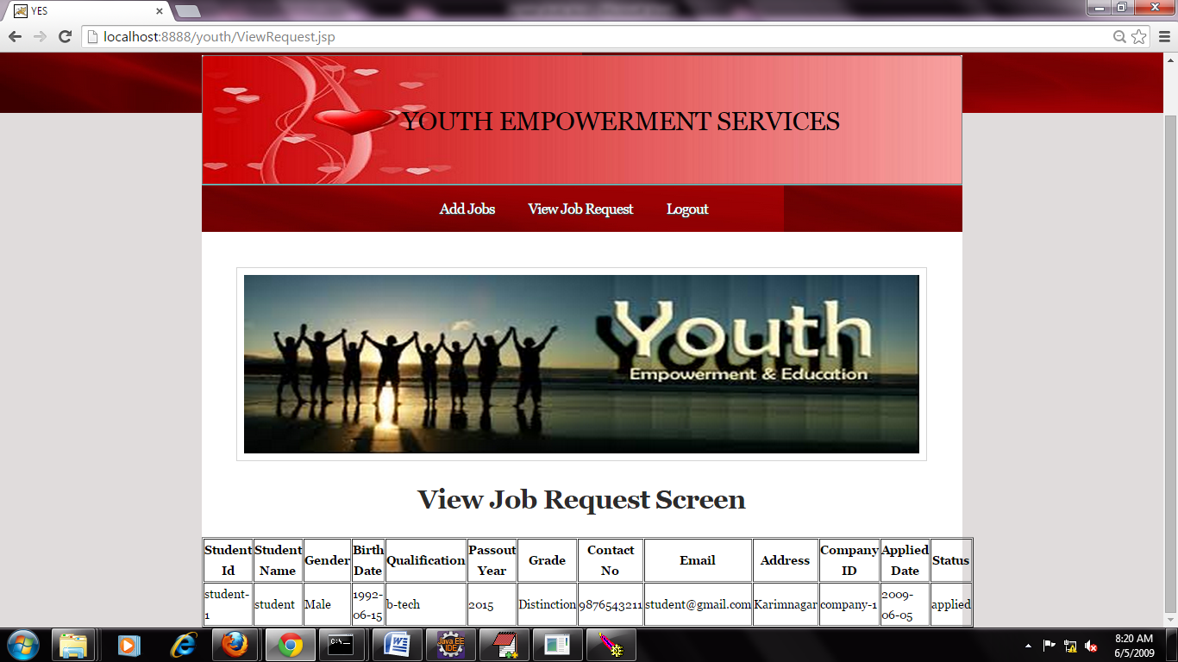

Finally click on logout button.